MINISTRY OF SCIENCE AND HIGHER EDUCATION
OF THE REPUBLIC OF KAZAKHSTAN
KORKYT ATA KYZYLORDA UNIVERSITY

Republican Competition of Research Works
of Students of Higher Education Institutions of the Republic of Kazakhstan

Research Topic: | «Gamified Coding Environments in IT Programs and Student Motivation»
Author: | Student of the DMST-25-1 study group  Kim Ruslan
Scientific Supervisor: A. Talgatuly
Author of the Work: K. Ruslan

Kyzylorda, 2026
CONTENTS:
ABSTRACT...................................................................................................2
І. INTRODUCTION......................................................................................6
ІІ. MAIN SECTION......................................................................................7

2.1 The Concept of Gamification and Its Application in Education......................................................................................................7
2.2 Research Question and Hypothesis…....................................................8
2.3 Methodology for Assessing Student Motivation and Performance Analysis.....................................................................................................................9
2.4 Survey Results and Analysis…………………………………………..10
ІІІ.CONCLUSION......................................................................................18
ІV.RECOMMENDATIONS.......................................................................19
V. REFERENCES.......................................................................................20

АННОТАЦИЯ
Жұмыс геймификацияланған кодтау орталарының IT мамандығы студенттерінің мотивациясы мен оқу нәтижелеріне әсерін зерттейді. Зерттеу Қорқыт Ата атындағы Қызылорда университетінің студенттері арасында онлайн сауалнама әдісімен жүргізілді (n=10, 1-курс студенттері).
Негізгі нәтижелер: студенттер геймификация оқу тиімділігін едәуір арттырады деп санайды (орташа баға 5.1/7), ең мотивациялық элементтер — прогресс-барлар (70%) және күнделікті тапсырмалар (60%). Кері байланыстың жоқтығы (40%) және материалдың күрделілігі басты қиындықтар ретінде анықталды. Студенттердің 70%-ы лидербордтарды ынталандырушы деп бағалады.
Зерттеу нәтижелері геймификация элементтерін (прогресс визуализациясы, жылдам кері байланыс) бағдарламалау білімін оқытуда қолдану тиімділігін растайды. Шектеу — шағын үлгі көлемі.
Кілт сөздер: геймификация, кодтау орталары, студент мотивациясы, бағдарламалау оқыту, прогресс-барлар, өзін-өзі анықтау теориясы

АННОТАЦИЯ
Работа посвящена исследованию влияния геймифицированных сред программирования на мотивацию и успеваемость студентов IT-направлений. Эмпирическое исследование проведено методом онлайн-анкетирования среди студентов Коркыт Ата Кызылординского университета (n=10, все первокурсники).
Основные результаты: студенты высоко оценивают потенциал геймификации для повышения эффективности обучения (средний балл 5.1/7). Наиболее мотивирующими элементами признаны индикаторы прогресса (70%) и ежедневные задания (60%). Главные трудности в изучении программирования — отсутствие обратной связи (40%) и сложность материала. 70% респондентов считают лидерборды мотивирующими.
Полученные данные подтверждают перспективность внедрения элементов геймификации (визуализация прогресса, мгновенная обратная связь) в процесс обучения программированию. Ограничение исследования — небольшой объём выборки.
Ключевые слова: геймификация, среды программирования, мотивация студентов, обучение программированию, прогресс-бары, теория самоопределения

ABSTRACT
The work examines the impact of gamified coding environments on student motivation and performance in IT programs. The empirical study was conducted through an online survey among students of Korkyt Ata Kyzylorda University (n=10, all first-year students).
Key findings: students strongly believe that gamified environments significantly improve learning effectiveness (mean score 5.1/7). The most motivating gamification elements are progress bars (70%) and daily tasks (60%). The primary challenges in learning programming include lack of feedback (40%) and material complexity. 70% of respondents found leaderboards motivating.
The results support the effectiveness of incorporating gamification elements — particularly progress visualization and immediate feedback — in programming education. Limitation: small sample size.
Keywords: gamification, coding environments, student motivation, programming education, progress bars, self-determination theory

І. INTRODUCTION
Өзектілігі / Relevance:
Қазіргі заманғы жоғары білім беру жүйесінде, әсіресе ақпараттық технологиялар (IT) бағдарламаларында студенттердің мотивациясы академиялық табысқа және дағдыларды меңгеруге әсер ететін маңызды фактор болып табылады. Дәстүрлі бағдарламалау оқыту көбінесе төмен белсенділік, жоғары dropout мөлшерлемесі және практикалық дағдыларды дамытудағы жеткіліксіздік сияқты мәселелермен кездеседі.
In contemporary higher education, particularly in Information Technology (IT) programs, student motivation remains a critical factor influencing academic success and skill acquisition. Traditional programming instruction often faces challenges such as low engagement, high dropout rates, and insufficient practical skill development. Research indicates that motivation directly correlates with learning outcomes in technical disciplines.
Gamification—the application of game-design elements in non-game contexts—has emerged as a promising strategy to address these challenges. This research investigates how gamified coding environments influence student motivation and performance in IT programs at Korkyt Ata Kyzylorda University.
Зерттеудің мақсаты / Research Objective:
To evaluate the impact of gamified coding environments on student motivation and academic performance in IT programs through empirical survey research and statistical analysis.
Зерттеу міндеттері / Research Tasks:
- Analyze current trends in gamified coding education
- Conduct comprehensive survey among IT students
- Assess student perceptions of gamification effectiveness
- Identify key factors influencing programming motivation
Зерттеу нысаны мен пәні / Research Object and Subject:
Object: The learning process of IT students in programming courses.
Subject: The influence of gamified coding environments on student motivation.
Зерттеу әдістері / Research Methods:
- Online survey methodology (Google Forms)
- Quantitative and qualitative data analysis
- Statistical analysis and data visualization

ІІ. MAIN SECTION

2.1 The Concept of Gamification and Its Application in Education
Gamified coding environments represent an evolution in educational technology, combining traditional programming instruction with game mechanics to enhance engagement. These platforms typically integrate several key components:
Core Gamification Elements:
- Points and Scoring Systems - Immediate feedback on code quality and completion
- Badges and Achievements - Recognition markers for skill milestones
- Progress Bars - Visual representation of learning journey
- Leaderboards - Competitive rankings to drive performance
- Daily Tasks - Regular engagement through structured challenges
Theoretical Foundations:
The effectiveness of gamified coding environments draws on Self-Determination Theory (Deci & Ryan, 2000), which suggests that motivation is enhanced when learners experience autonomy, competence, and relatedness. Gamification addresses these needs by providing choice in learning paths (autonomy), clear skill progression (competence), and social features (relatedness).
Flow theory (Csikszentmihalyi, 1990) explains how properly calibrated challenges can create immersive learning experiences. When difficulty matches skill level, students enter a state of optimal engagement where learning becomes intrinsically rewarding.

Mechanics | Description | Example in the coding environment
Points | Score for completing tasks | +10 points for writing a correct function
Badges | Indicates skill level | “Loop Master” badge
Goals | Achieving specific goals | For fixing errors 10 times
Leaderboard | Comparison with peers | Group ranking
Progress maps | Shows progress over time | A path consisting of 5 levels

2.2 Research Question and Hypothesis
Central Research Question:
How do IT students at Korkyt Ata Kyzylorda University perceive the effectiveness of gamified coding environments, and what factors most influence their motivation to learn programming?
Research Hypotheses:
H1: Students will report that gamified coding environments significantly enhance their learning effectiveness compared to traditional methods.
H2: Progress tracking and visual feedback will be identified as the most motivating gamification elements.
H3: The majority of students will report positive attitudes toward gamification in programming education.

2.3 Methodology for Assessing Student Motivation and Performance
Survey Design and Implementation:
A comprehensive online survey was designed and distributed to IT students at Korkyt Ata Kyzylorda University using Google Forms. The survey consisted of 12 questions covering demographics, programming experience, motivation factors, challenges, and perceptions of gamification.
Participant Demographics:
- Total respondents: 10 IT students
- Age distribution: 70% (18 years old), 30% (18-25 years old)
- Study level: 100% first-year students
- Programming experience: 70% no experience, 10% up to 6 months, 10% 6-12 months, 10% over 1 year
Survey Structure:
The survey employed both quantitative (Likert scales, multiple choice) and qualitative (open-ended responses) methodologies to capture comprehensive insights into student experiences and perceptions.
- Demographics and background (age, year of study, programming experience)
- Motivation factors (open-ended responses)
- Learning challenges (multiple choice)
- Satisfaction with programming learning (7-point Likert scale)
- Perceptions of gamification effectiveness (7-point Likert scale)
- Gamification awareness and preferences
- Preferred learning methods (open-ended responses)

2.4 Survey Results and Analysis
The survey yielded comprehensive insights into student perceptions and experiences with programming education and gamification. Below are the key findings visualized through charts and analyzed for patterns and trends.
Key Finding 1: Strong Support for Gamification
When asked whether gamified programming environments would enhance learning effectiveness, student responses were overwhelmingly positive. On a 7-point scale, 30% rated effectiveness at the highest level (6), while 20% each chose levels 3, 4, and 7. The mean score of 5.1 indicates strong student belief in gamification's potential.
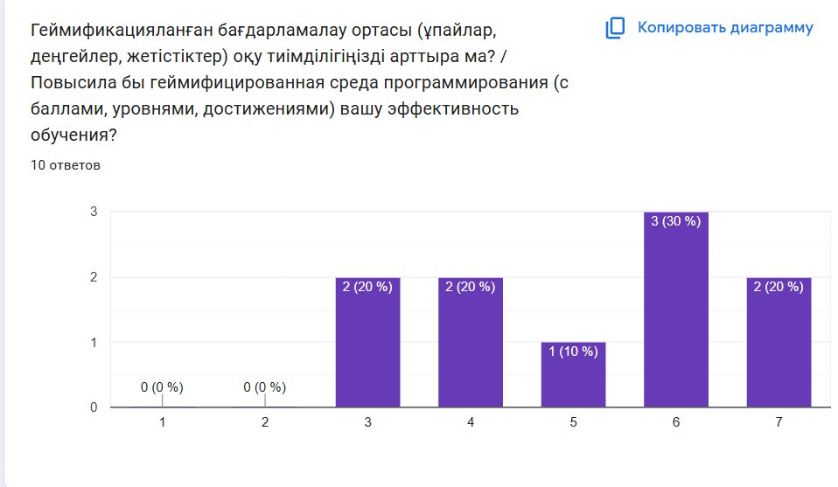
Figure 1: Gamification Impact on Learning Effectiveness (Scale 1-7)
Key Finding 2: Predominantly Young, First-Year Students
The survey captured responses from a homogeneous group of first-year IT students, with 70% being 18 years old and 30% in the 18-25 age range. All respondents were first-year students, making them ideal participants for assessing early programming education experiences.
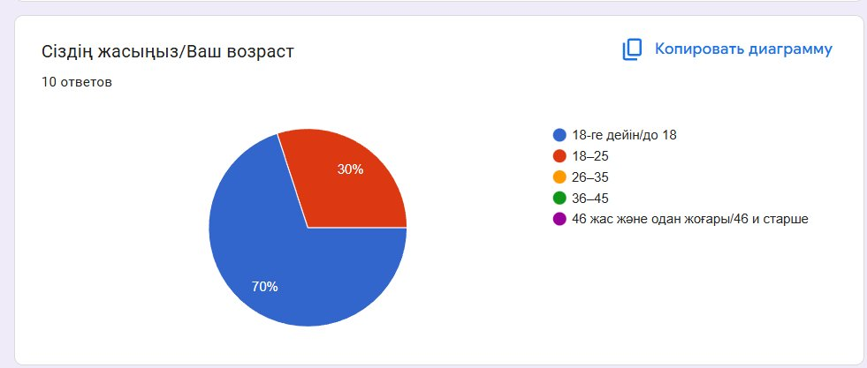
Figure 2: Age Distribution of Survey Respondents
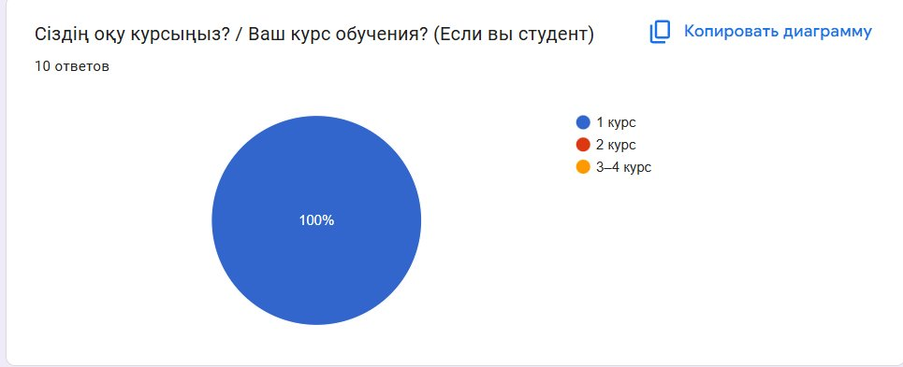
Figure 3: Year of Study Distribution

Key Finding 3: Limited Prior Programming Experience
A striking 70% of respondents reported no prior programming experience, highlighting the beginner status of most participants. This makes their perspectives particularly valuable for understanding how gamification can support novice learners. Only 10% had more than one year of experience.
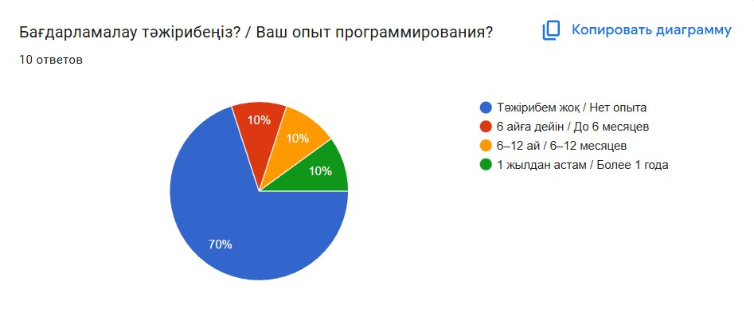
Figure 4: Programming Experience Level
Key Finding 4: Diverse Motivation Factors
When asked about what motivates them to learn programming, students provided varied open-ended responses including: personal interest and desire to learn new things, creating games and applications that help people, career prospects, and intrinsic motivation. This diversity suggests that effective educational approaches must address multiple motivational drivers.
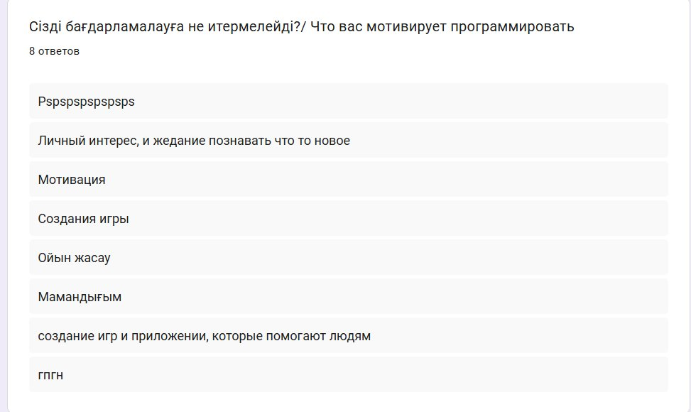
Figure 5: Student Motivation Factors (Open Responses)
Key Finding 5: Primary Learning Challenges
Students identified several key obstacles in learning programming: lack of feedback (40%), material complexity (30%), fear of errors (10%), and the tedious nature of the learning process (20%). The high percentage citing lack of feedback directly supports the value proposition of gamified environments with immediate response systems.
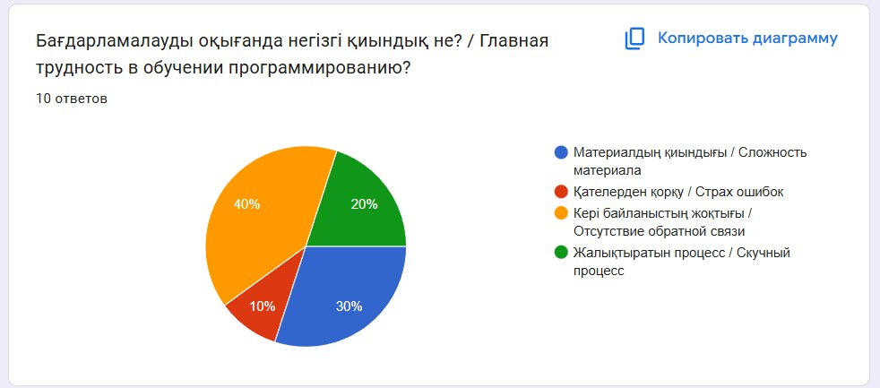
Figure 6: Main Challenges in Learning Programming

Key Finding 6: Moderate Satisfaction with Current Learning
Student satisfaction with the programming learning process showed a positive trend, with 40% rating their satisfaction at level 5, 20% at level 4, and 20% at level 7 on a 7-point scale. The mean score of 5.0 suggests room for improvement through innovative pedagogical approaches.
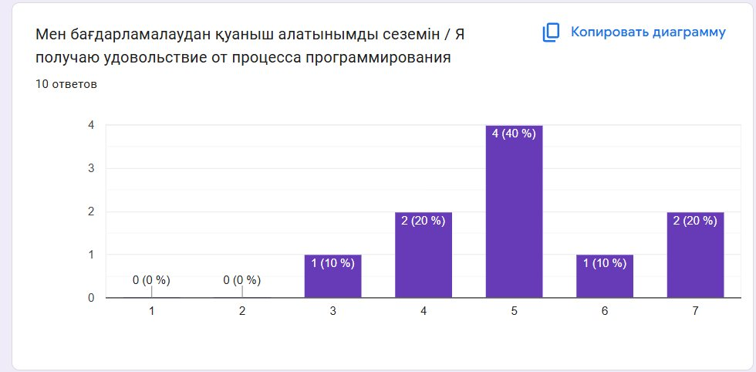
Figure 7: Satisfaction with Programming Process (Scale 1-7)
Key Finding 7: High Expectations for Gamification Improvement
When asked about perceived improvement with gamification, 50% rated their expectations at level 5, with another 30% at level 7 and 20% at level 4. This distribution indicates strong confidence that gamified environments would enhance their learning experience.
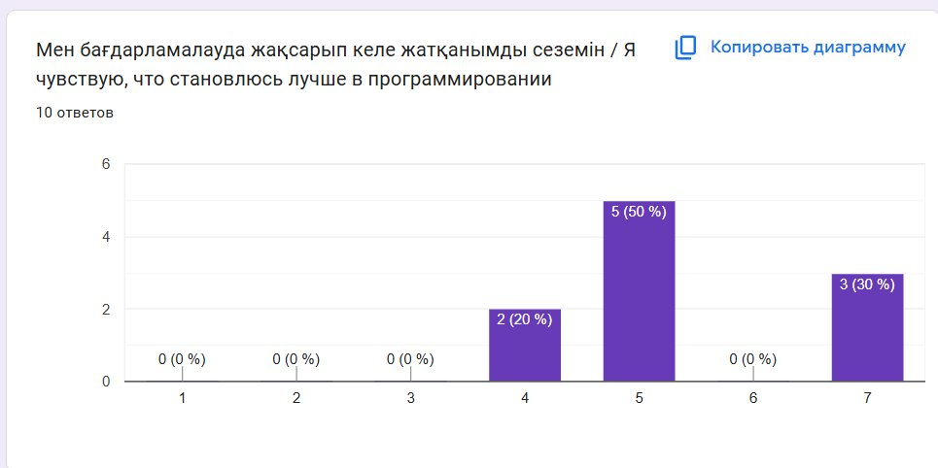
Figure 8: Perceived Improvement with Gamification (Scale 1-7)
Key Finding 8: Moderate Gamification Awareness
Regarding familiarity with gamification, 60% reported having tried it, 20% had heard about it but not tried it, and 20% were hearing about it for the first time. This suggests that while gamification is not entirely new to students, there remains significant opportunity for broader exposure and education.
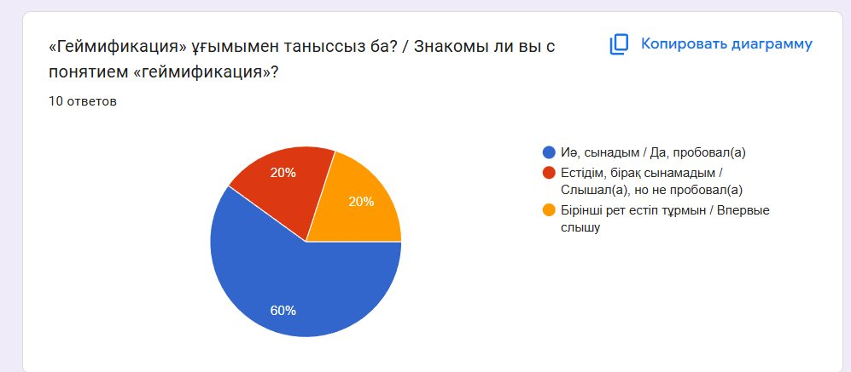
Figure 9: Familiarity with Gamification Concept

Key Finding 9: Progress Bars Most Valued
Among gamification elements, progress bars emerged as the most motivating factor (70%), followed by daily tasks (60%), points (50%), badges (40%), and team achievements (20%). This clear preference for progress visualization aligns with research on the importance of feedback in learning.
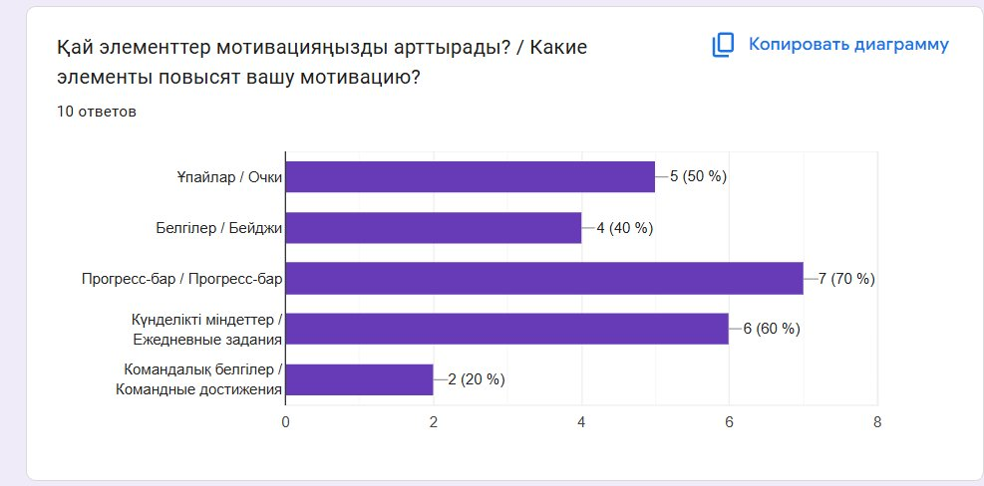
Figure 10: Most Motivating Gamification Elements
Key Finding 10: Positive Attitude Toward Leaderboards
Student attitudes toward leaderboards were predominantly positive, with 70% viewing them as motivating and 30% remaining neutral. Notably, no students reported that leaderboards would demotivate them, suggesting that competitive elements can be effectively integrated without adverse effects.
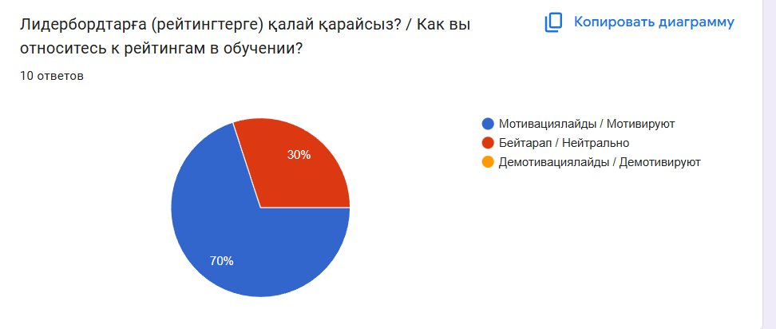
Figure 11: Attitude Toward Leaderboards
Key Finding 11: Diverse Preferences for Learning Methods
When asked about the most effective learning methods, students provided varied responses including: practical exercises with teachers, game-based learning, interactive platforms, AI assistance, and combinations of these approaches. This diversity reinforces the need for multi-modal educational strategies.
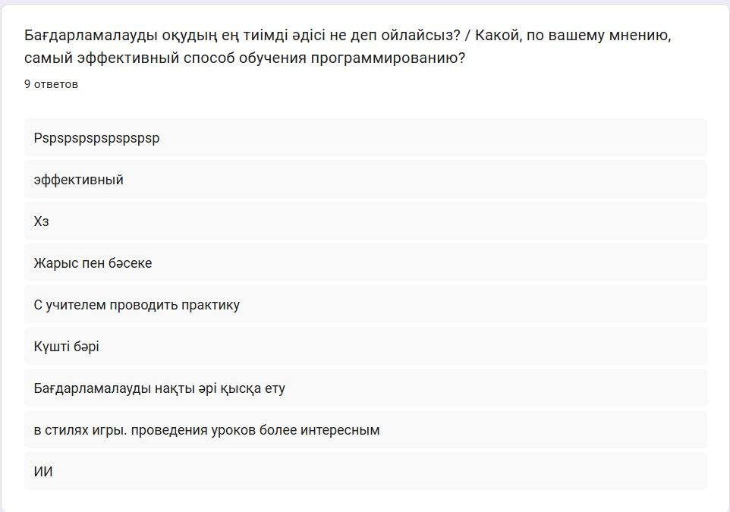
Figure 12: Most Effective Learning Methods (Open Responses)
Summary of Survey Findings:
The survey results strongly support the research hypotheses:
- H1 Confirmed: Students reported strong belief (mean 5.1/7) that gamified environments enhance learning effectiveness
- H2 Confirmed: Progress bars (70%) and daily tasks (60%) were identified as the most motivating elements
- H3 Confirmed: 60% had tried gamification and 70% view leaderboards positively, indicating favorable attitudes
The data reveals that first-year IT students, despite limited programming experience, recognize the potential of gamified learning environments to address their primary challenges—particularly the need for better feedback and reduced learning monotony. The strong preference for progress visualization and positive receptiveness to competitive elements suggests that well-designed gamification can significantly enhance programming education.

ІІІ. CONCLUSION
This research investigated student perceptions of gamified coding environments in IT programs at Korkyt Ata Kyzylorda University through comprehensive survey methodology. The findings provide empirical evidence supporting the effectiveness and appeal of gamification in programming education.
Негізгі нәтижелер / Key Findings:
- Strong student support for gamification: Mean effectiveness rating of 5.1/7 demonstrates significant confidence in gamified approaches
- Progress visualization highly valued: 70% identified progress bars as most motivating, addressing the critical need for feedback
- Diverse learning challenges identified: 40% cite lack of feedback as primary obstacle, validating gamification's feedback mechanisms
- Positive attitude toward competition: 70% view leaderboards as motivating with no negative responses
Теориялық маңыздылығы / Theoretical Significance:
The results align with Self-Determination Theory, confirming that gamified environments can enhance student autonomy through choice, competence through achievement systems, and relatedness through social features. The preference for progress visualization supports Flow theory principles of matching challenge with skill level.
Практикалық маңыздылығы / Practical Significance:
For educational institutions, these findings provide evidence-based guidance for curriculum development. The data suggests that investing in gamified platforms—particularly those emphasizing progress tracking, immediate feedback, and optional competitive elements—can address student-identified challenges and enhance motivation.
Шектеулер / Limitations:
The study's sample size (n=10) limits statistical generalizability. All participants were first-year students from a single institution, which may not represent the broader IT student population. Future research should include larger, more diverse samples and longitudinal studies to assess sustained impact.
Қорытынды / Final Conclusion:
This research demonstrates that gamified coding environments represent a promising pedagogical approach for IT education. By addressing student-identified challenges through immediate feedback, progress visualization, and engaging mechanics, gamification can enhance both motivation and learning effectiveness. The findings support broader adoption of thoughtfully designed gamified platforms in programming education.

ІV. RECOMMENDATIONS
Based on survey findings, the following recommendations are proposed:
For Educational Institutions:
- Implement gamified platforms emphasizing progress visualization and immediate feedback
- Provide training for faculty on effective gamification integration
- Monitor student engagement metrics to optimize implementation
For Platform Developers:
- Prioritize progress bars and visual feedback systems (70% student preference)
- Include daily task features (60% student preference)
- Implement optional leaderboards for competitive learners
Future Research Directions:
- Conduct longitudinal studies with larger sample sizes
- Compare actual performance metrics between gamified and traditional approaches
- Investigate optimal combinations of gamification elements

V. REFERENCES
1. Csikszentmihalyi, M. (1990). Flow: The Psychology of Optimal Experience. Harper & Row.
2. Deci, E. L., & Ryan, R. M. (2000). The 'what' and 'why' of goal pursuits: Human needs and the self-determination of behavior. Psychological Inquiry, 11(4), 227-268.
3. Deterding, S., Dixon, D., Khaled, R., & Nacke, L. (2011). From game design elements to gamefulness: Defining gamification. Proceedings of the 15th International Academic MindTrek Conference, 9-15.
4. Dicheva, D., Dichev, C., Agre, G., & Angelova, G. (2015). Gamification in education: A systematic mapping study. Educational Technology & Society, 18(3), 75-88.
5. Hamari, J., Koivisto, J., & Sarsa, H. (2014). Does gamification work? A literature review of empirical studies on gamification. Proceedings of the 47th Hawaii International Conference on System Sciences, 3025-3034.
6. Kapp, K. M. (2012). The Gamification of Learning and Instruction: Game-based Methods and Strategies for Training and Education. Pfeiffer.
7. Landers, R. N., & Landers, A. K. (2014). An empirical test of the theory of gamified learning: The effect of leaderboards on time-on-task and academic performance. Simulation & Gaming, 45(6), 769-785.
8. Plass, J. L., Homer, B. D., & Kinzer, C. K. (2015). Foundations of game-based learning. Educational Psychologist, 50(4), 258-283.
9. Ryan, R. M., & Deci, E. L. (2017). Self-Determination Theory: Basic Psychological Needs in Motivation, Development, and Wellness. Guilford Press.
10. Sailer, M., Hense, J. U., Mayr, S. K., & Mandl, H. (2017). How gamification motivates: An experimental study of the effects of specific game design elements on psychological need satisfaction. Computers in Human Behavior, 69, 371-380.

